16 August 2019

Post-election report

The Pharmacy Guild of Australia
Western Australia Branch
Casual Vacancy election
E2019/131
Contents
Election(s) Covered in this Report 3
Rules 3
Roll of Voters 3
Irregularities 3
Other Matters 4
Signed 4
Attachments 4
A. Declaration of Results for Uncontested Offices – WA 4

Election(s) Covered in this Report
Organisation: Western Australia Branch
Election: Casual Vacancy
Election Decision No/s: E2019/131

Rules
Rules used for the election: [175V: Incorporates alterations of 06/02/2017 [2016/318]]
(replaces 25/09/2014 [R2014/4] version)

Rules difficult to apply/interpret: None
Model Rule reference (if any): N/A
For more details see the Model Rules on the AEC website: (https://www.aec.gov.au/About_AEC/AEC_Services/Industrial_Elections)

Roll of Voters
As there were no contested offices, no Roll of Voters was required.

Irregularities
Details of written allegations of irregularities, and action taken by AEC: N/A
Other irregularities identified, and action taken: N/A

Other Matters
Returning Officer actions required (Section 193): No

Signed
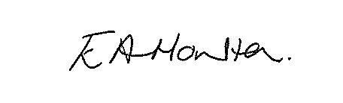
Liz Houlton
Returning Officer
Australian Electoral Commission
E: waelections@aec.gov.au
P: 08 6363 8056
16 August 2019

Attachments

- Declaration of Results for Contested Offices – WA

Western Australia Branch
Alternate National Councillor (1)
Candidates
PEARSON Donna

Branch Vice President (1)
Candidates
PEARSON Donna

