S3B PADS ORDER FORM Prices Effective 1 January 2022
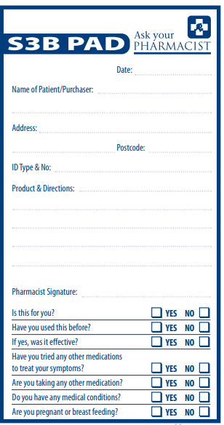

Member Price | $3.00 each  (GST Included) | Qty  (Minimum Order Qty is 10)

Postage charges including GST

Postage for 10 Pads $20.00

Postage for 20 Pads $25.00

Stock appearance may vary from this image

Please fill out this form

and fax or email to the

Pharmacy Guild (SA Branch)
Facsimile: (08) 8333 1729
Email: guildsa@sa.guild.org.au

Pharmacy Name | Click or tap here to enter text.
Contact Person | Click or tap here to enter text.
Telephone | Click or tap here to enter text.
Postal Address | Click or tap here to enter text.
Email for Invoice | Click or tap here to enter text.

