Novel Coronavirus:
Pharmacy advice
Australia is closely monitoring an outbreak of respiratory illness caused by a novel (new) coronavirus first identified in Wuhan, Hubei Province, China. People most at risk of contracting coronavirus are people who have been in mainland China recently or have been in close contact with someone who has a confirmed case of coronavirus.
The most up to date information, updates and resources can be found on the Australian Government Department for Health website:
www.health.gov.au/health-topics/novel-coronavirus-2019-ncov

If a customer presents with flu-like symptoms:
- If a customer presents to the pharmacy seeking advice on, or displaying flu-like symptoms (fever, cough, shortness of breath, sore throat) pharmacists are encouraged to ask:
  - Whether they have been in mainland China recently (14 days), or
  - Whether they have been in contact with people with confirmed coronavirus infection.
- If the answer is YES:
  - Advise the customer to put on a mask (single-use surgical) and
  - Advise them to go home immediately, and to call their GP to make an appointment. They must not go to their GP without calling ahead advising of recent travel history or contact with people with coronavirus infection.
  - Provide them with the suspected case fact sheet:
www.health.gov.au/sites/default/files/documents/2020/02/novel-coronavirus-2019-ncov-information-for-people-with-a-suspected-case-novel-coronavirus-2019-ncov-information-sheet-for-people-with-a-suspected-case.pdf
  - If the person is very sick, they should go to a local hospital. The person must call the hospital first so they can prepare for their arrival.

Advice for customers:
- Customers and pharmacy staff should be reminded of good hygiene practices to minimise the spread of infection, including regular handwashing and covering the mouth when coughing or sneezing.
- See the ‘Cover your cough’ poster which can be displayed in the pharmacy:
  - Cover Your Cough poster A4 - English
  - Cover Your Cough poster A4 - Chinese
- Fact sheets are available to print for customers from the Australian Government Department for Health website: www.health.gov.au/health-topics/novel-coronavirus-2019-ncov

Further information:
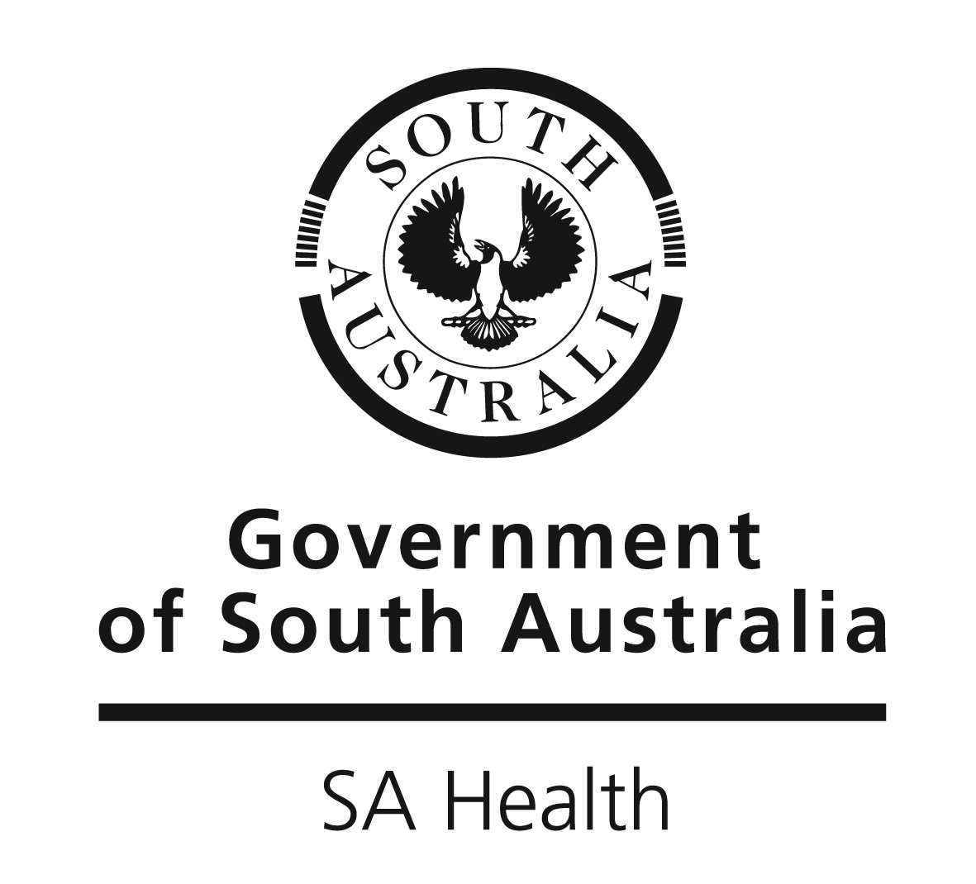
SA Health: www.sahealth.sa.gov.au/novelcoronavirus

