**S3B PADS ORDER FORM Prices Effective 1 January 2025**

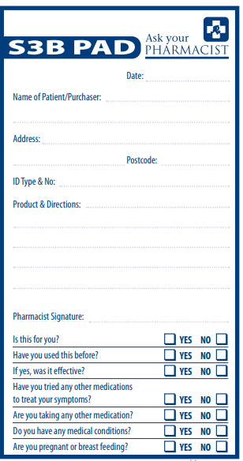

|  |  |
| --- | --- |
| **Member Price**  **$3.00 each**  ***(GST Included)*** | **Order Quantity _____________**  **(Minimum Order Quantity is 10)** |

Postage charges including GST

Postage for 10 Pads $20.00

Postage for 20 Pads $25.00

Stock appearance may vary from this image

Please fill out this form and

email to the

Pharmacy Guild (SA Branch)

**Email:** [**guildsa@sa.guild.org.au**](mailto:guildsa@sa.guild.org.au)

|  |  |
| --- | --- |
| **Pharmacy Name** |  |
| **Contact Person** |  |
| **Telephone** |  |
| **Postal Address** |  |
| **Email for Invoice** |  |